**Q1. Explain Gauss-Seidel method used to solve a linear set of equations.**

In certain cases, such as when a system of equations is large, iterative methods of solving equations are more advantageous. Elimination methods, such as Gaussian elimination, are prone to large round-off errors for a large set of equations. Iterative methods, such as the Gauss-Seidel method, give the user control of the round-off error. Also, if the physics of the problem are well known, initial guesses needed in iterative methods can be made more judiciously leading to faster convergence. What is the algorithm for the Gauss-Seidel method? Given a general set of n equations and n unknowns, we have

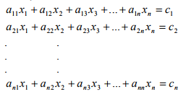

If the diagonal elements are non-zero, each equation is rewritten for the corresponding unknown, that is, the first equation is rewritten with x1 on the left hand side, the second equation is rewritten with x2 on the left hand side and so on as follows

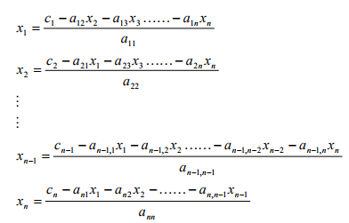

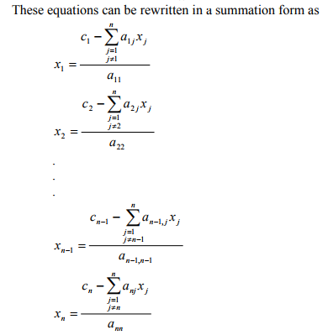

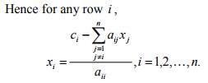

**Gauss-Seidel – Convergence criteria:**

The solution of linear equations by iterative methods requires for convergence that the absolute magnitudes of all the eigenvalues of the iteration matrix should be less than unity.

The Gauss-Seidel method converges if the number of roots inside the unit circle is equal to the order of the iteration matrix.

Start iteration process by guessing and and always using the most recent values of x’s

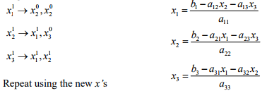

Check for convergence: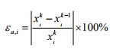

For all i’s where k = current iteration, k-1 = previous iterations

Diagonal Dominance – the diagonal element of a row should be greater than the sum of all other row elements

The convergence properties of the Gauss–Seidel method are dependent on the matrix *A*. Namely; the procedure is known to converge if either:

* *A* is symmetric positive-definite, or
* *A* is strictly or irreducibly diagonally dominant.

The Gauss–Seidel method sometimes converges even if these conditions are not satisfied.

**Q2. Explain Gauss-Jordan elimination method used to solve a linear set of equations.**

The following row operations on the augmented matrix of a system produce the augmented matrix of an equivalent system, i.e., a system with the same solution as the original one.

• Interchange any two rows.

• Multiply each element of a row by a nonzero constant.

• Replace a row by the sum of itself and a constant multiple of another row of the matrix.

For these row operations, we will use the following notations.

• Ri ↔ Rj means: Interchange row i and row j.

• αRi means: Replace row i with α times row i.

• Ri + αRj means: Replace row i with the sum of row i and α times row j.

The Gauss-Jordan elimination method to solve a system of linear equations is described in the following steps. 1. Write the augmented matrix of the system.

2. Use row operations to transform the augmented matrix in the form described below, which is called the reduced row echelon form (RREF).

(a) The rows (if any) consisting entirely of zeros are grouped together at the bottom of the matrix.

(b) In each row that does not consist entirely of zeros, the leftmost nonzero element is a 1 (called a leading 1 or a pivot).

(c) Each column that contains a leading 1 has zeros in all other entries.

(d) The leading 1 in any row is to the left of any leading 1’s in the rows below it.

3. Stop process in step 2 if you obtain a row whose elements are all zeros except the last one on the right. In that case, the system is inconsistent and has no solutions. Otherwise, finish step 2 and read the solutions of the system from the final matrix.

**Note:** When doing step 2, row operations can be performed in any order. Try to choose row operations so that as few fractions as possible are carried through the computation. This makes calculation easier when working by hand.

**Example:** Solve the following system by using the Gauss-Jordan elimination method.

x + y + z = 5

2x + 3y + 5z = 8

4x + 5z = 2

**Solution:**

The augmented matrix of the system is the following

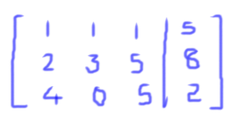

We will now perform row operations until we obtain a matrix in reduced row echelon form.

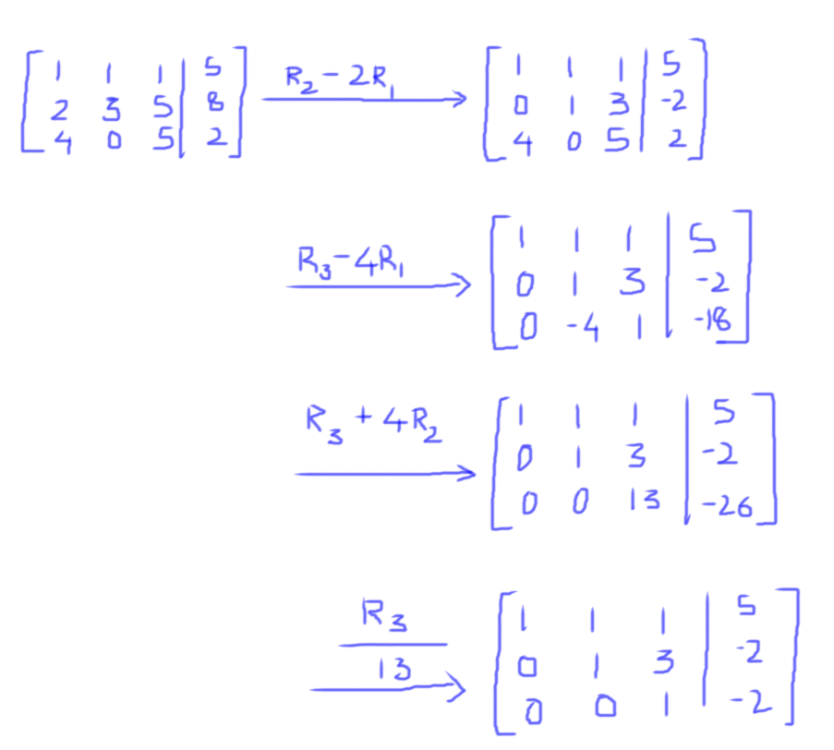

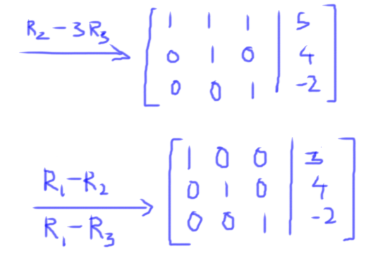

From this final matrix, we can read the solution of the system.

**x = 3, y = 4 and z = -2**

**Q3. If A and B are the two matrices of the same order then prove**

**(A + B)2 = A2 + B2 + 2AB Only if AB = BA**

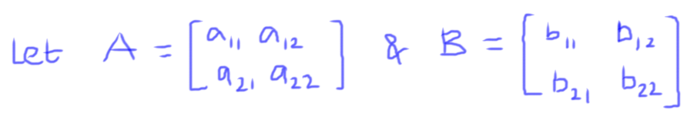

Let’s calculate (A+B)2

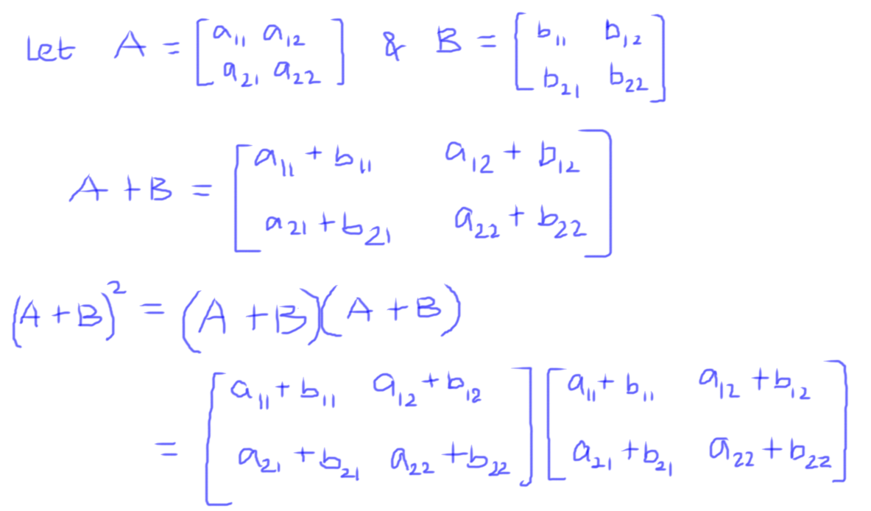

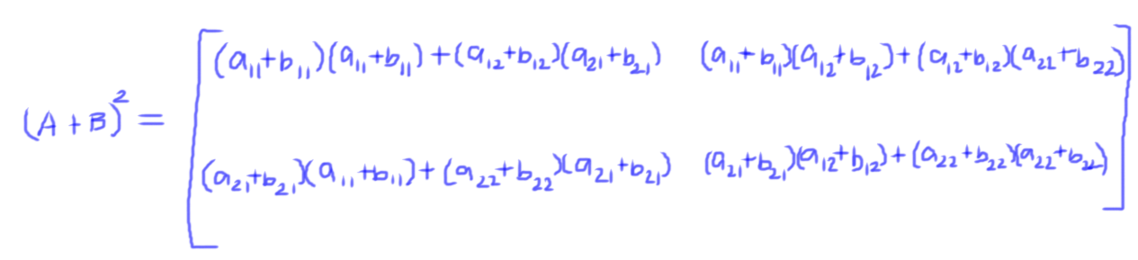

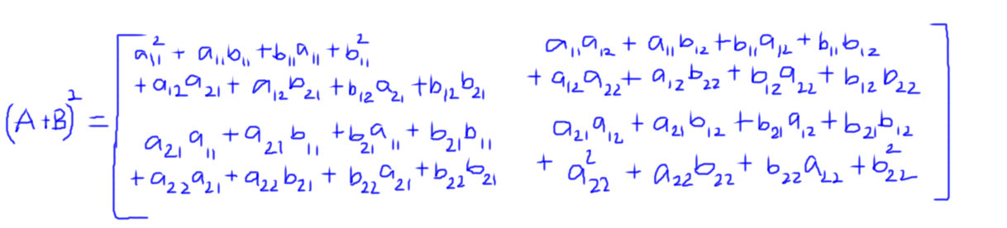

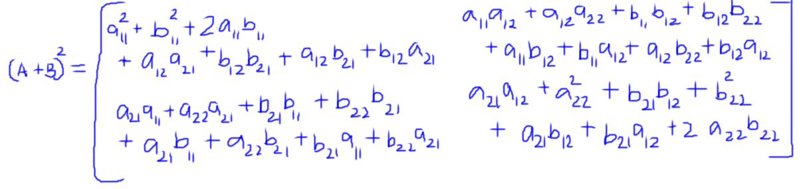

Let’s calculate A2 + B2 + 2AB

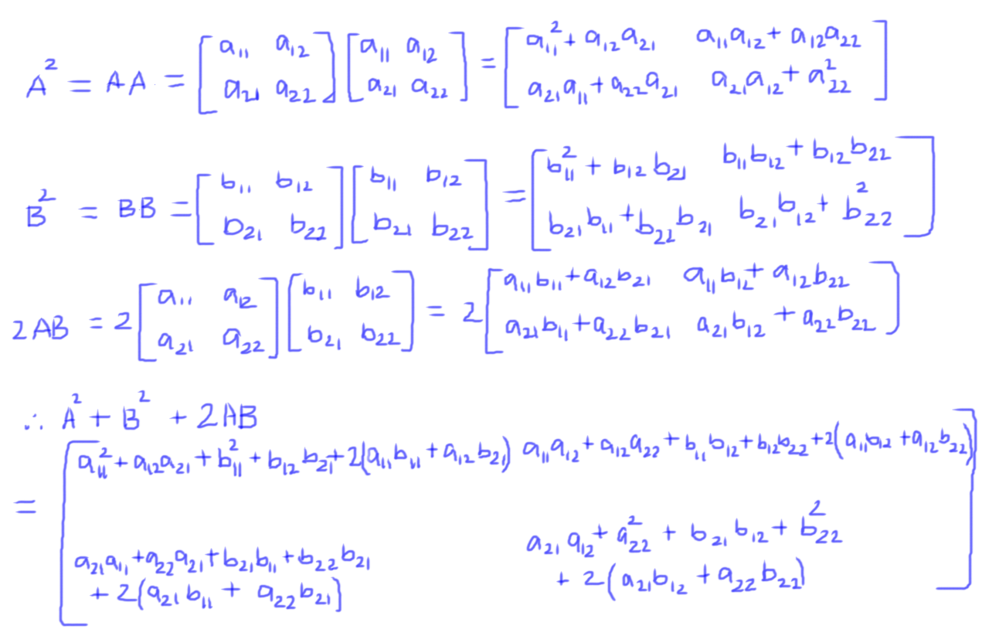

If (A + B)2 = A2 + B2 + 2AB, then the correspond elements should also be equal.

Hence:

a112 + b112 + 2a11b11 + a12a21 + b12b21 + a12b21 + b12a21 = a112 + a12a21 + b112 + b12b21 + 2(a11b11 + a12b21)

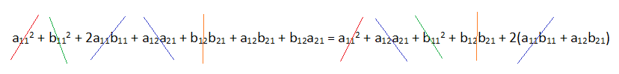

a12b21 + b12a21 = 2a12b21

b12a21 = a12b21

b12a21 = a12b21 if and only if AB=BA

**Q4. If s and t are scalars, and A and B are matrices, prove that:**

1. **𝐼𝐴=𝐴**
2. **𝑠(𝐴+𝐵)=𝑠𝐴+𝑠𝐵**
3. **(𝑠+𝑡)𝐴=𝑠𝐴+𝑡𝐴**
4. **𝑠(𝑡𝐴)=(𝑠𝑡)𝐴**
5. **𝐴+0=𝐴**
6. **𝐴−𝐴=0**
7. **𝐼𝐴=𝐴**

Let’s prove this by taking an example

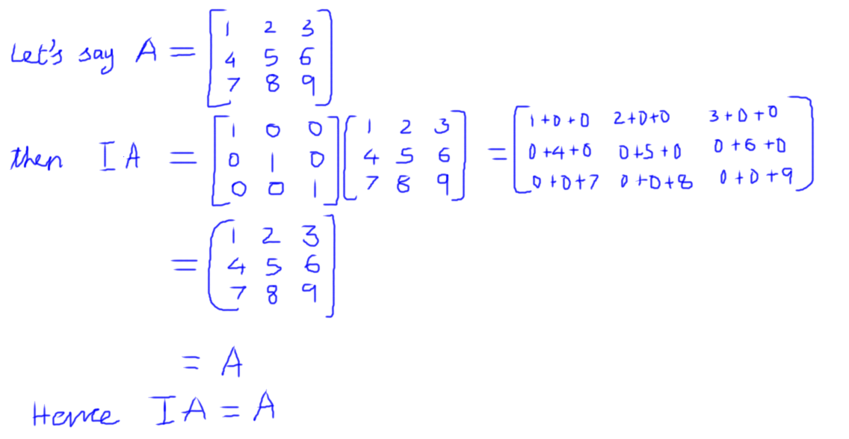

1. **𝑠(𝐴+𝐵)=𝑠𝐴+𝑠𝐵**

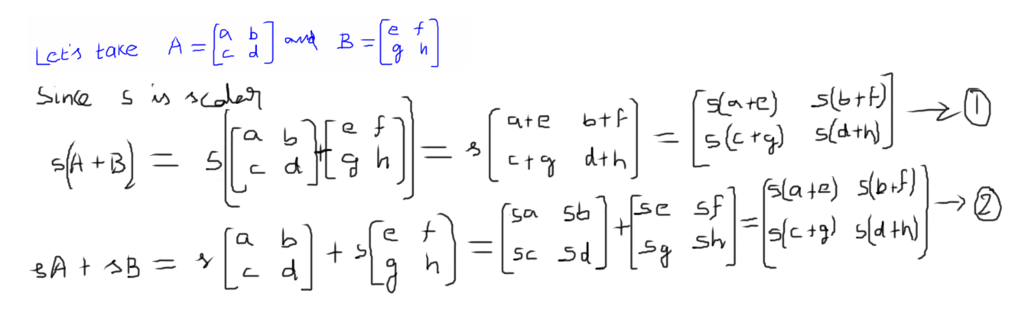

Since RHS of (1) and (2) are equal, LHS should also be equal.

Hence, **s(A+B) = sA + sB**

1. **(𝑠+𝑡)𝐴=𝑠𝐴+𝑡𝐴**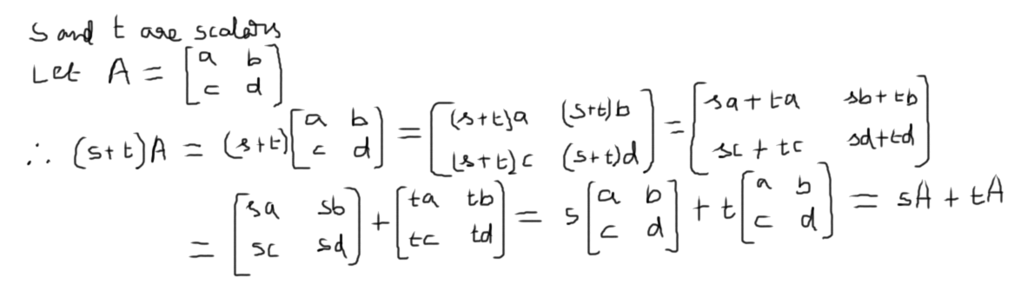

Hence proved that **(𝑠+𝑡)𝐴=𝑠𝐴+𝑡𝐴**

1. **𝑠(𝑡𝐴)=(𝑠𝑡)𝐴**

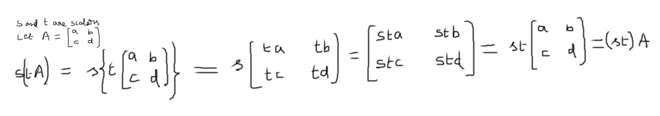

Hence proved that **𝑠(𝑡𝐴)=(𝑠𝑡)𝐴**

1. **𝐴+0=𝐴**

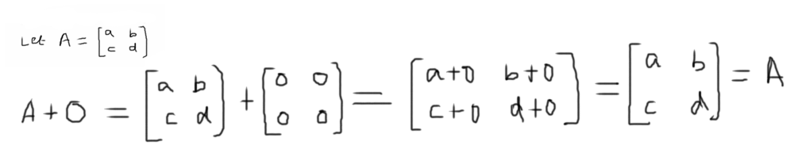

Hence proved that **A+O = A**

1. **𝐴−𝐴=0**

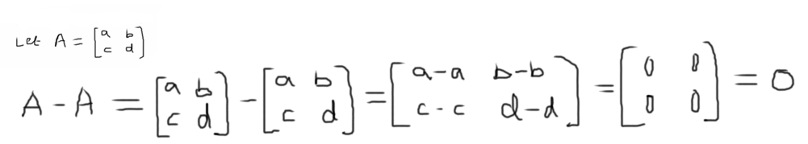

Hence proved that **A – A = O**

**Q5. If both AB and BA are feasible, prove that 𝐴𝐵≠𝐵𝐴.** 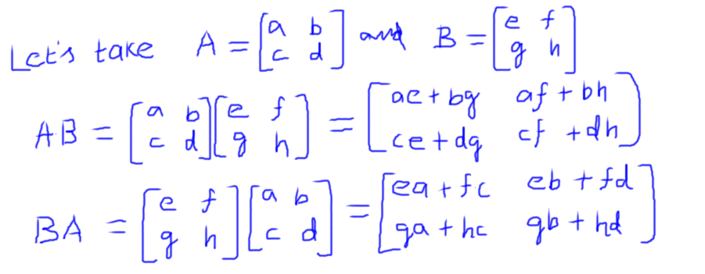

If AB = BA, then corresponding elements should also be equal.

Let’s check whether the corresponding elements are equal or not.

We can notice that, 1x1 element of both the matrices are not equal, i.e., ae + bg ≠ ea + fc

Hence, AB ≠ BA

**Q6. Prove that:**

1. **[𝐴𝑇]𝑇=𝐴**

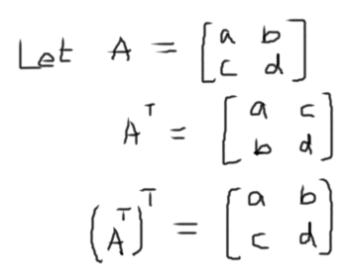

[𝐴𝑇]𝑇=𝐴

1. **[𝐴+𝐶]𝑇=𝐴𝑇+𝐶𝑇**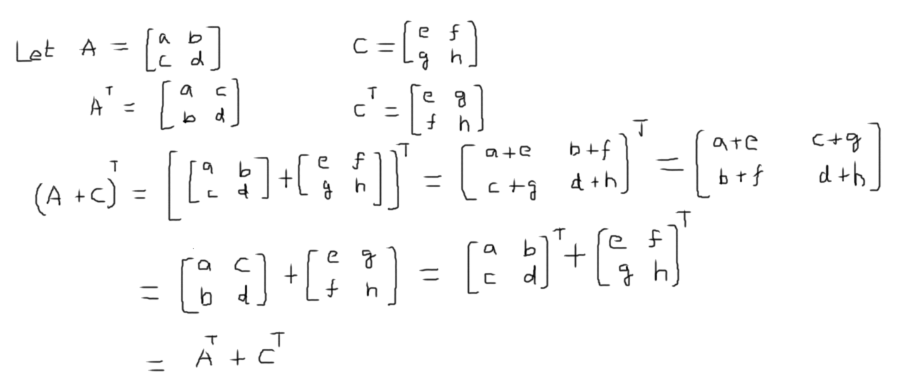
2. **[𝐴𝐵]𝑇=𝐵𝑇.𝐴𝑇**

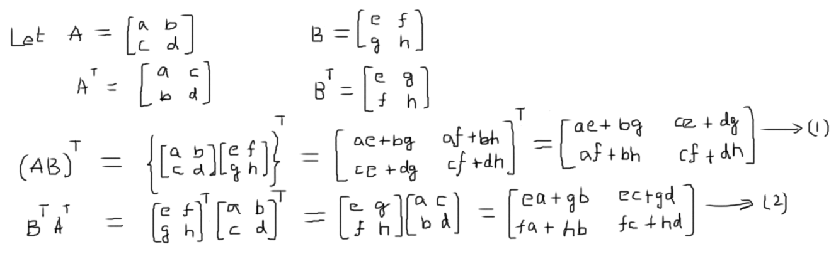

Since RHS of (1) and (2) are equal, [𝐴𝐵]𝑇=𝐵𝑇𝐴𝑇

**Q7. if**

**A = [12−1352], B = [2−13145]**

**Find 2A, -3B, (A - 2B), (3A + 4B)**

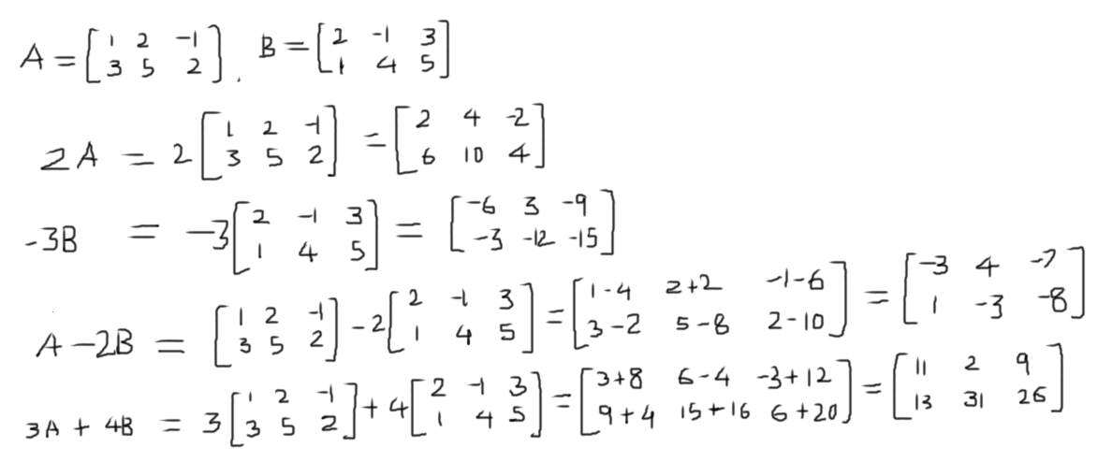

**Q8. If**

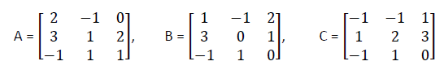

**Find the matrix D such that 2A + B -3C + 2D = A + 4C**

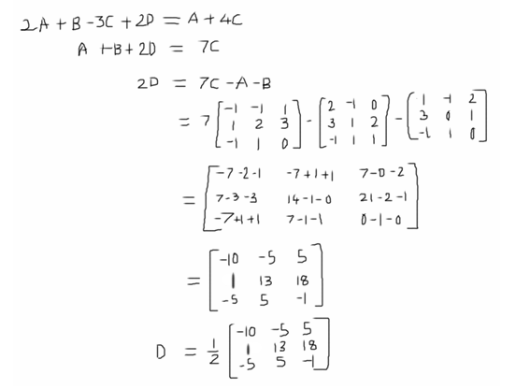

**Q9. If**

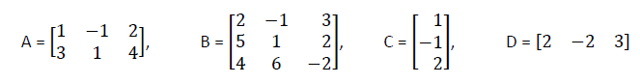

**Find, if possible, AB, BC, CA, DC, DB, AD and CD.**

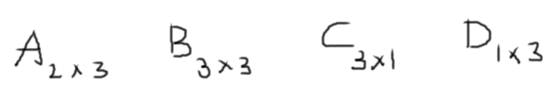

AB is possible and would be 2x3 matrix

BC is possible and would be 3x1 matrix

CA is not possible

DC is possible and would be 1x1 matrix

DB is possible and would be 1x3 matrix

AD is not possible

CD is possible and would be 3x3 matrix

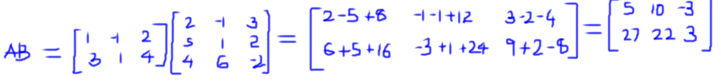

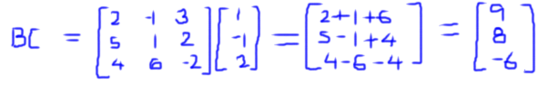

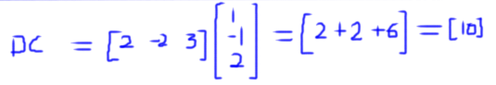



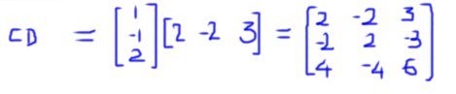

**Q10. Find A2, A3, A4 if**

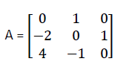

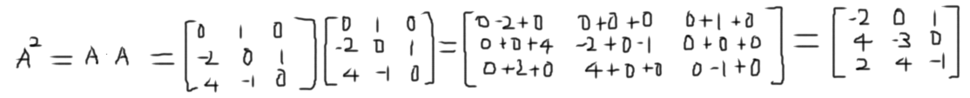



**References:**

[**http://mathforcollege.com/nm/mws/gen/04sle/mws_gen_sle_txt_seidel.pdf**](http://mathforcollege.com/nm/mws/gen/04sle/mws_gen_sle_txt_seidel.pdf)

[**https://dl.acm.org/citation.cfm?id=2613304&preflayout=flat**](https://dl.acm.org/citation.cfm?id=2613304&preflayout=flat)